Insert the title of your paper here
Max Mustermann¹, Miriam Mustermann², Markus Mustermann²
¹HTW Berlin
Industrial Environmental Computing Unit
Wilhelminenhofstr. 75 A
12459 Berlin
Max.Mustermann@htw-berlin.de
²Technische Universität Berlin
Straße des 17. Juni 135
10623 Berlin
Miriam.Mustermann@tu-berlin.de
Markus.Mustermann@tu-berlin.de
Abstract: Abstract text (the maximum number of words that should be used for the abstract is 250). Please use the font Times New Roman, size 10, or choose the style “Abstract Text” from the available styles.

Heading first level
Insert your text here. Please use the font Times New Roman, size 10 or choose the style “Standard Text” from the available styles.

Heading second level

Heading third level

Length of the paper
The overall length of the paper should be at least 2 pages and at most 12 pages (given the respective style usage). In case you feel that you absolutely have to go beyond the 10 pages limit, please get in contact with the editors first.

Citing a reference
To cite a reference in the text, use the author-date method as in (Chien 1989). For a work by three or more authors, use an abbreviated form. For example, a work by Banks, Carson and Nicol would be cited in one of the following ways: (Banks et al. 2000).
Parenthetical citations are enclosed in parentheses ( ), not square brackets [ ]. The items in a series of such citations are usually separated by commas. If an item in the series of parenthetical citations contains punctuation because (for example) it refers to a work with three or more coauthors, then all items must be separated by semicolons.
The following is a list of correct forms of citations:
- (Brown & Edwards 1993),
- (Brown & Edwards 1993, Smith 1997), and
- (Brown & Edwards 1992; Brown et al. 1995; Smith 1997).
The following is a list of incorrect forms of citations:
- Brown & Edwards [1993],
- (Brown & Edwards, 1993),
- (Brown & Edwards 1992, Brown et al. 1995, Smith 1997)

Footnotes
Do not use footnotes; instead incorporate such material into the text directly or parenthetically.

Tables and figures
Style Name | Description
Abstract Heading | Heading style for abstract
Abstract Text | The style for the abstract text
Author Affiliation | Style for the authors affiliation
Author Name | Style for the authors name(s)
Table 1: Defined Word Styles
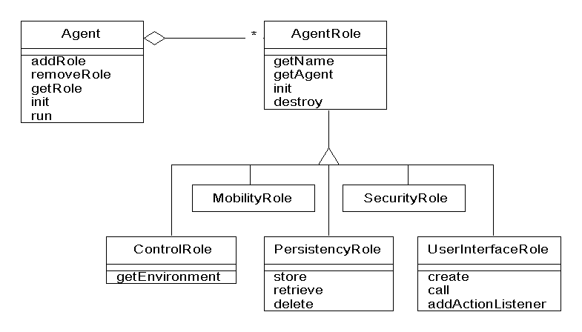
Figure 1: Description of the image
Table and figure description are to be situated beneath the respective table or figure, please choose the Table and Figure Description Style (Font: Times New Roman, Size 10, Centered, Paragraphs).
Literature
Banks, J., J. S. Carson, B. L. Nelson, and D. M. Nicol. (2000): Discrete-Event System Simulation. 3rd ed. Upper Saddle River, New Jersey: Prentice-Hall, Inc.
Chien, C. (1989): “Small Sample Theory for Steady State Confidence Intervals.” Technical Report No. 37, Department of Operations Research, Stanford University, Stanford, California.
Steiger, N. M. (1999): “Improved Batching for Confidence Interval Construction in Steady-State Simulation.” Ph.D. thesis, Department of Industrial Engineering, North Carolina State University, Raleigh, North Carolina. http://www.lib.ncsu.edu/resolver/1840. 16/4713 [Accessed February 7, 2011].

